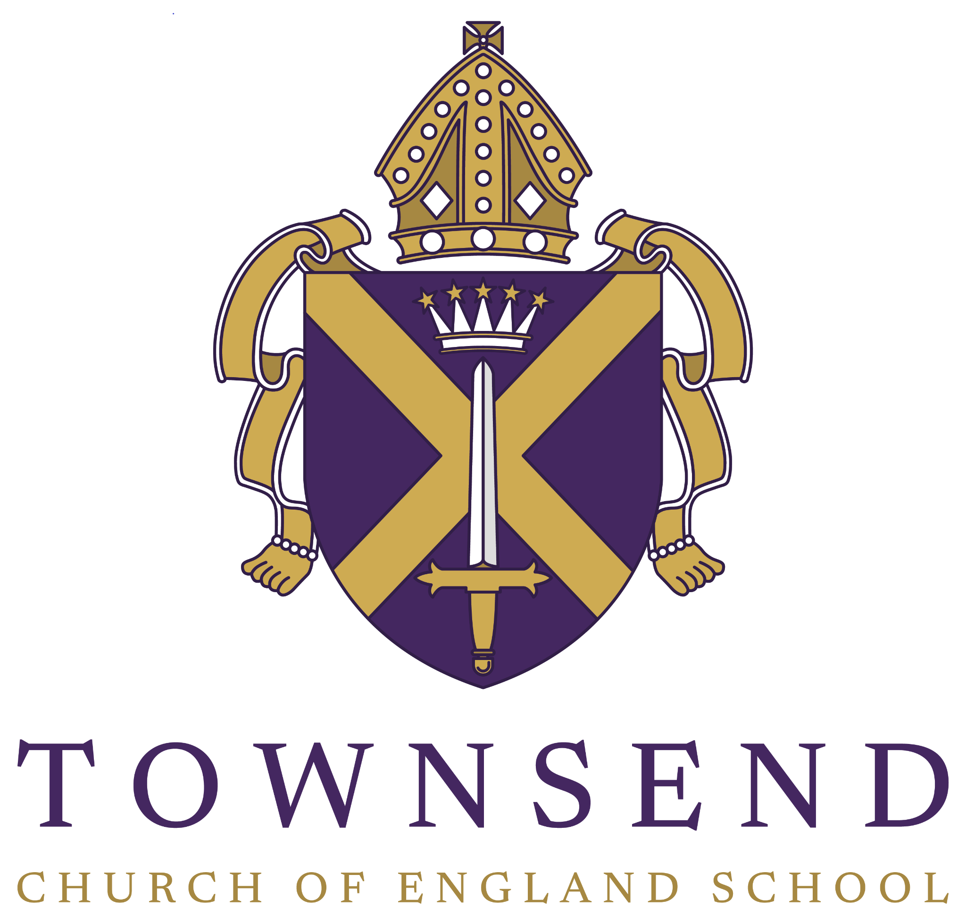

School Calendar

Parent/Carer

2023-2024

| **Autumn 1 – September/October 2023** | | |
| --- | --- | --- |
| **SEPTEMBER 2023** | | |
| Fri | 1 | INSET – Staff Training (School closed to students) |
| Mo | 4 | INSET – Staff Training (School closed to students) |
| Tu | 5 | 8:45am Year 7 Start School  8:45am Year 12 Induction Day |
| We | 6 | All Students Return to School |
| Fr | 8 | School Photographs |
| We | 20 | **12:30pm School Closes for students**  6:00-8:45pm Open Evening |
| Fr | 22 | Year 11 History Trip (to be confirmed) |
| **Sa/Su** | **23/24** | 23rd and 24th – Bronze Duke of Edinburgh Qualifying Expedition  23rd and 24th – Model Society Show: 10am-5pm |
| We | 27 | 5:00pm Year 7 Information Evening (Y7 parents/carers to attend) |
| Th | 28 | 2:00pm Dedication Cathedral Service (parents/carers welcome, further details issued nearer the time) |
| **OCTOBER 2023** | | |
| Mo | 16 | Early Application UCAS Deadline  7:00 – 8:00pm Meet the Headteacher Evening for Parents/Carers of students in Years 7-9 (no students to attend) |
| We | 18 | 3:45-5:00pm Primary Teacher Visits |
| Th | 19 | Years 9 and 10 Art Trip (to be confirmed) |

**23rd – 27th October – ½ Term Holiday**

| **Autumn 2 – November/December 2023** | | |
| --- | --- | --- |
| **NOVEMBER 2023** | | |
| Mo | 30 Oct | 8:00am – 3:00pm Flu Vaccinations (all years) |
| We | 1 | 7:00 – 8:00pm Meet the Headteacher Evening for Parents/Carers of students in Years 10-13 (no students to attend) |
| Mo | 6 | Textiles Fashion Trip |
| We | 8 | 5:00 - 8:00pm Year 11 Parent/Carer Consultation Evening (Y11 parents/carers to attend) |
| Mo | 20 | Years 11/12 Maths Inspiration Trip (to be confirmed) |
| We | 22 | Year 11 GCSE French Speaking Trial Exams |
| Th | 23 | GCSE Music Trip (to be confirmed)  Year 11 GCSE French Speaking Trial Exams  7:00pm Sixth Form Information Evening (for current Year 11 students and parents/carers) |
| Mo | 27 | Year 11 Trial Exams for 2 weeks (further details issued nearer the time) |
| We | 29 | Year 9 Humanities Trip (to be confirmed) |
| **DECEMBER 2023** | | |
| Mo | 4 | 6:00pm Year 10 Work Experience Information Evening |
| We | 6 | 2:00pm Christingle Cathedral Service (parents/carers welcome, further details issued nearer the time) |
| Th | 7 | 5:00 – 8:00pm Year 10 Parent/Carer Consultation Evening (Y10 parents/carers to attend) |
| Fr | 8 | Year 11 Trial Exams Finish  7:00pm Christmas Pantomime |
| We | 20 | 12:30pm School Ends |

**21st December – 3rd January – Christmas Holiday**

| **Spring 1 – January/February 2024** | | |
| --- | --- | --- |
| **JANUARY 2024** | | |
| Th | 4 | INSET – Staff Training (School closed to students) |
| Fr | 5 | INSET – Staff Training (School closed to students) |
| Mo | 8 | Year 13 Trial Exams for 1 week (further details issued nearer the time) |
| Fr | 12 | Year 13 Trial Exams Finish |
| We | 17 | Year 11 London Arts Fair Trip (to be confirmed) |
| Th | 18 | 5:00 – 8:00pm Year 7 Parent/Carer Consultation Evening (Y7 parents/carers to attend) |
| Fr | 19 | Sixth Form Applications Deadline for Year 11 Students |
| Th | 25 | 5:00 – 8:00pm Years 12/13 Parent/Carer Consultation Evening (Y12/13 parents/carers to attend) |
| We | 31 | Equal Consideration UCAS Application Deadline |
| **FEBRUARY 2024** | | |
| Sa/Su | 3/4 | 4th – Maths/MfL Trip to Paris Departs |
| Mo | 5 | Maths/MfL Trip to Paris |
| Tu | 6 | Maths/MfL Trip to Paris Returns |
| Th | 8 | 5:00pm Year 11 Intervention Evening (parents/carers by invite only) |
| We | 14 | 2:00pm Ash Wednesday Cathedral Service (parents/carers welcome, further details issued nearer the time) |
| Th | 15 | 8:55am – 1:15pm Year 11 Food Preparation and Nutrition Exam |

**19th – 23rd February – ½ Term Holiday**

| **Spring 2 – February/March 2024** | | |
| --- | --- | --- |
| **FEBRUARY 2024** | | |
| Mo | 26 | Year 13 Royal Courts of Justice Trip |
| **MARCH 2024** | | |
| Mo | 4 | Year 11 Trial Exams in Core Subjects Start |
| We | 6 | 5:00 – 8:00pm Year 8 Parent/Carer Consultation Evening (Y8 parents/carers to attend) |
| Fr | 8 | Year 11 Trial Exams in Core Subjects Finish |
| Mo | 11 | Year 8 Humanities Trip (to be confirmed) |
| Fr | 22 | 7:00pm Creative and Performing Arts Display (in school, further details to be issued nearer the time) |
| We | 27 | 6:00pm Year 10 Study Support Evening |
| Th | 28 | 12:30pm School Ends |

**29th March – 12th April – Easter Holiday**

| **Summer 1 – April/May 2024** | | |
| --- | --- | --- |
| **APRIL 2024** | | |
| We | 17 | Year 10 Geography Trip to Swanage Departs |
| Th | 18 | Year 10 Geography Trip to Swanage |
| Fr | 19 | Year 10 Geography Trip to Swanage Returns |
| We | 24 | KS4 BFI French Trip (to be confirmed)  5:00 – 8:00pm Year 9 Parent/Carer Consultation Evening (Y9 parents/carers to attend) |
| Mo | 29 | Year 10 Work Experience – for 1 week |
| Tu | 30 | Year 10 Work Experience |
| **MAY 2024** | | |
| We | 1 | Year 10 Work Experience  GCSE French Speaking Exams |
| Th | 2 | Year 10 Work Experience  GCSE French Speaking Exams |
| Fr | 3 | Year 10 Work Experience  Year 11 Year Group Photograph (to be confirmed) |
| Mo | 6 | **BANK HOLIDAY – School Closed** |
| Tu | 7 | Year 11 Final GCSE Art Exam |
| We | 8 | Year 11 Final GCSE Art Exam |
| Th | 9 | **National Exams Start (GCSE and A Level)**  2:00pm Ascension Day Cathedral Service |
| Fr | 10 | 1:45pm Year 13 Leavers Assembly |
| Mo | 13 | Year 7 and 8 End of Year Exams in class – spread throughout the week |
| Mo | 20 | Year 7 and 8 End of Year Exams in class – spread throughout the week |

**27th – 31st May – ½ Term Holiday**

| **Summer 2 – June/July 2024** | | |
| --- | --- | --- |
| **JUNE 2024** | | |
| Mo | 3 | National Exams  Year 9 End of Year Exams – all week |
| Th | 6 | Year 7 Humanities Trip (to be confirmed) |
| Mo | 10 | National Exams |
| Mo | 17 | National Exams  Year 10 and 12 Exam Week |
| Th | 20 | KS3 BFI French Trip (to be confirmed)  11:30am Year 11 Celebration Event |
| Fr | 21 | 7:30pm Year 11 Prom |
| Mo | 24 | Year 12 Work Shadowing – all week  4:00 – 5:30pm New Intake Evening for Year 6 students and parents/carers |
| Tu | 25 | Year 11 into Sixth Form Induction Day  4:00 – 5:30pm New Intake Evening for Year 6 students and parents/carers |
| We | 26 | Year 11 into Sixth Form Induction Day  4:00 – 5:30pm New Intake Evening for Year 6 students and parents/carers |
| Fr | 28 | 12:00 – 3:25pm Sports Day |
| **JULY 2024** | | |
| Mo | 1 | Year 7 Residential Trip  Reserve Sports Day |
| Tu | 2 | Year 7 Residential Trip |
| We | 3 | Year 7 Residential Trip |
| Th | 4 | 7:00pm School Show Performance (further information to be issued nearer the time) |
| Fr | 5 | 7:00pm School Show Performance (further information to be issued nearer the time) |
| Th | 11 | Year 7 Work Shadowing Day  Year 6 Transition Day (for new Year 6 students) |
| Fr | 12 | Whole School Enrichment Day (for all students) |
| Mo | 15 | 2:00pm Year 7 Celebration Event (parent/carers welcome) |
| Tu | 16 | 2:00pm Year 8 Celebration Event (parent/carers welcome) |
| We | 17 | 2:00pm Year 9 Celebration Event (parent/carers welcome) |
| Th | 18 | 2:00pm Year 10 Celebration Event (parent/carers welcome)  2:00pm Year 12 Celebration Event |
| Fr | 19 | 12:30pm School Ends |

**Parent/Carer Evenings**

| **Year Group** | **Parent/Carer Evening**  **5-8pm** |
| --- | --- |
| 7 | Thursday 18th January |
| 8 | Wednesday 6th March |
| 9 | Wednesday 24th April |
| 10 | Thursday 7th December |
| 11 | Wednesday 8th November |
| 12 | Thursday 25th January |
| 13 | Thursday 25th January |

**Results Days**

| **Results** |  |
| --- | --- |
| A Level | Thursday 15th August |
| GCSE | Thursday 22nd August |