Summer School 2021

Review of Summer School 2021
In July, we welcomed our incoming Year 7 cohort to our Transition Summer School. This weeklong event included a range of learning and enrichment activities, where students were encouraged to interact with others from our 52 “feeder” primary schools. As predicted, the uptake for the week was high with 101 of the 119 students attending. Led by new Head of Key Stage 3, Miss Gordon, and supported by Deputy Head, Mr Buckland and Assistant Head, Miss Gibbons, a diverse programme of activities was planned and delivered. Teaching staff, learning support assistants, administration staff and Kate Barron (wellbeing) were all instrumental in the week being a success.
In the absence of other transition days and activities due to COVID-19 restrictions, this week provided a platform for all students – particularly our most vulnerable – to prepare for the new academic year. It gave us, as teachers, a wealth of information about the new year group and enabled us to plan extra support accordingly.
The aims of the week were to:
· Build friendships with fellow pupils,
· Familiarise themselves with their new school environment and teaching staff,
· Create shared learning experiences, on which to build a community.
Alongside curriculum led activities – which included English, Maths, Science, Art, French, Food Technology and Swimming – external companies delivered a day of team building activities, African drumming, and a workshop about building new friendships with all students (STEP). On the Thursday and Friday, students were taken by coach to Stanborough Lakes, Welwyn Garden City, where they enjoyed paddleboarding and kayaking.

Funding
The funding for summer school was based on the number of students in the previous Year 7 cohort. Of this funding, £18,985.30 was allocated to staffing costs, ensuring that the students had access to a range of expertise for learning and pastoral care. Extra support was provided for those students with Educational Health Care Plans and additional medical needs. £7,681.18 covered the costs of a varied programme of activities, with some being run by external agencies. The total cost claimed by the school was £26,666.48.

Pupil Voice
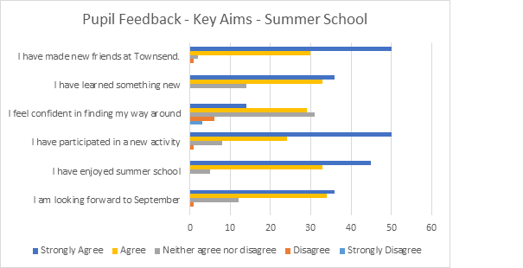Of the 101 students who attended at least one day of Summer School, 83 completed our feedback questionnaire. As illustrated above, over 80% of those have either agreed or strongly agreed with most statements. Their feedback and self-reflection helped to inform the planning of their first day in September, which included additional site familiarisation. Topics of discussion from the week, fed directly into Learning for Life sessions for the year group in September.

Pupil Comments
“Is it really only Tuesday? We feel like a year group already!”
“My favourite session was music because I learnt new things about drumming, which I didn’t know before.”
“My favourite was Science because the teacher trusted us enough to allow us to use fire and experiment.”
“I enjoyed working with my friends to make a display in Art.”
“I loved Science because I liked how cool the stuff is!”
“I enjoyed going to the lake and learning how to use kayaks and paddles.”
“The Hub Challenge was great because we worked as a team, and I enjoyed swimming because I think I improved a little bit.”
“I really enjoyed doing English because I enjoyed writing about the lighthouse and being imaginative.”
“My favourite session was food tech, because it taught me how to cook properly!”

Parent/carer Feedback
“I just wanted to say a huge thank you to all the staff for organising this week. My child had a fantastic time, and thoroughly enjoyed themselves, and was sad it had ended on Friday, which is particularly high praise as they were initially rather disgruntled about having to go to school in the summer holidays. They are now really looking forward to starting in September.”
If you had another day at summer school, what would you choose to do? Everything!
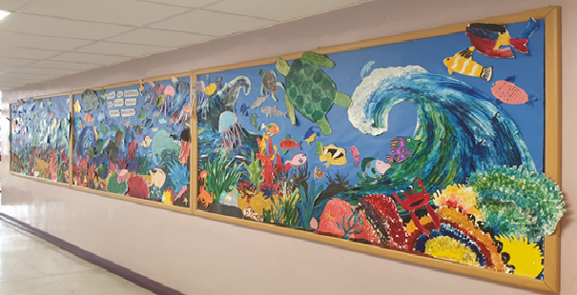
“We are all different, but we all swim in the same ocean.” Summer School 2021 Art Display.

